**Name: Seif El Din Ayman farouk** **ID: 222100792** **Program: Computer Engineering**

**Assignment 2.3.1**

# 1-The defining characteristics of Web 2.0 to Web 4.0.

• **Web 2.0**: Interactive, user-generated content.

• **Web 3.0**: Semantic web, AI, data interconnection.

• **Web 4.0**: Intelligent web, AI integration, seamless digital-physical interaction.

# 2- What are the key features of Web 2.0 and how it empowers the power of networks.

• **Social networking**: Connects users.

• **User-generated content**: Empowers communities.

• **Rich web apps**: Enhances interactivity.

# 3- What are the key features of Web 3.0 and how it empowers the meaning of data and knowledge connections.

• **Decentralization**: User control over data.

• **Semantic web**: Enhanced data understanding.

• **AI**: Intelligent applications

# 4-What are the key features of Web 4.0 and how it empowers intelligent connections.

• **Advanced AI**: Personalization.

• **Integration**: Physical-digital convergence.

• **Decentralization**: Improved security.

# 5- The importance of collective intelligence, social networking, social media and social bookmarking.

• **Social media**: Real-time sharing.

• **Networking**: Global connections.

• **Bookmarking**: Resource discovery.

# 6- How these technologies empower the current and future business plans.

• **Communication**: Better connections.

• **Data**: Informed decisions.

• **Customer engagement**: Direct interactions.

# 7- How do you intend to use the latest technologies in your profession?

Stay updated, improve user assistance, and provide relevant information efficiently.

There you go—concise yet comprehensive!

**ASSIGNMENT 2.3.2**

1. **Define the purpose of your intended website; it might be about a favorite hobby or subject, family business, a church, a mosque or club, a company etc.**

The purpose of my website its to give the audience a better music streaming service and its called harmofy

**2- What would you like the website to accomplish?Who is your intended audience?**

Anyone can listen to his favorite music there is no targeted audience

**What opportunities, problems, or issues does your planned website address?**

The opportunities that the website have a comprehensive selection of genres, artists, and tracks to cater to diverse tastes , the issues that can affect the website copyrights and Poor Licensing Agreements , Overloading with ads or poorly structured subscription plans can alienate users.

**5- What kind of content could be incorporated on your website?**

**How will the site serve the client?**

Keep users engaged with a wide range of content and features , Extensive catalog of tracks and albums across various genres.Curated playlists for different moods, activities, and genres.

**7- What's the best method for the user to do what's wanted?**

Ensure the website is intuitive and easy to navigate**.**

**8- How will users find the function?**

Users will easily locate functions through a well-organized navigation menu and a prominent search bar.

**9- How will the results of the function be received?**

Results will be displayed instantly on the page or sent via notifications or emails.

**10- What will the receiver do with the received entries?**

The receiver will review the entries and organize them accordingly, whether it's saving favorite tracks, compiling playlists, or analyzing feedback.

**11- How will the receiver deal with results?**

Depending on the results, actions might include personalizing user recommendations, improving services, or addressing feedback.

**12- What follow up will be needed?**

Regularly updating content and features

**13- List at least two related or similar sites found on the Web. Explain why you chose**

Spotify a very good and succeful music streaming service and simfy Africa the opposite in every thing

**14-** 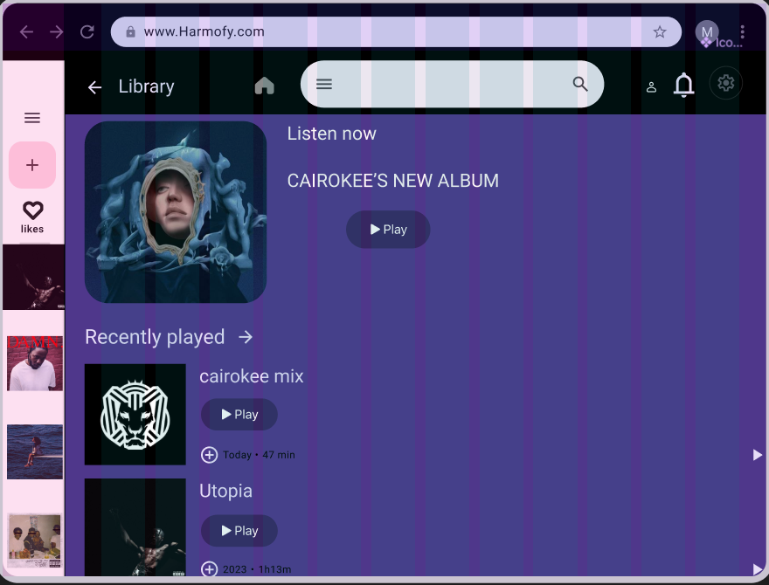

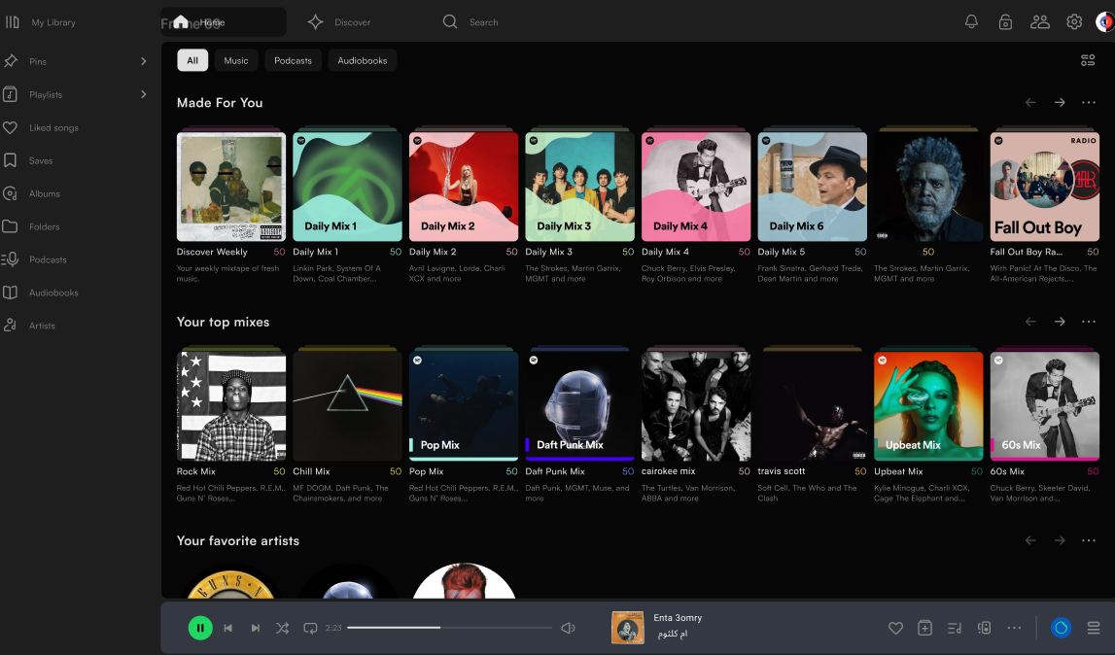

**• Facts and Text:**

* **Display the current song title and artist name prominently.**
* **Provide details like the album name and song duration.**
* **• Search bar for user queries.**
* **• Search results listing song titles, artists, and albums.**

**• Pictures:**

* **Include the album cover of the currently playing song.**

**• Audio:**

* **The main audio playback functionality, allowing users to play, pause, and skip tracks.**

**• User Inputs:**

* **Buttons for controlling playback (play, pause, next, previous).Volume slider or mute button.**
* <!DOCTYPE html>
* <html>
* <head>
* <!-- Basic -->
* <meta charset= />
* <meta http-equiv=content=\/>
* <!-- Mobile Metas -->
* <meta name=] content=/>
* <!-- Site Metas -->
* <meta name= content=" />
* <meta name= content="" />
* <meta name= content="" />
* <title>Neogym</title>
* <!-- slider stylesheet -->
* <link rel=om/ajax/libs/OwlCarousel2/2.3.4/assets/owl.carousel.min.css" />
* <!-- bootstrap core css -->
* <link rel=type= href=
* <!-- fonts style -->
* <link href= rel=>
* <!-- Custom styles for this template -->
* <link href= rel= />
* <!-- responsive style -->
* <link href=
* </head>
* <body class=>
* <div class=
* <!-- header section strats -->
* <header class=
* <div class=>
* <nav class=>
* <a class=href>
* <span>
* Neogym
* </span>